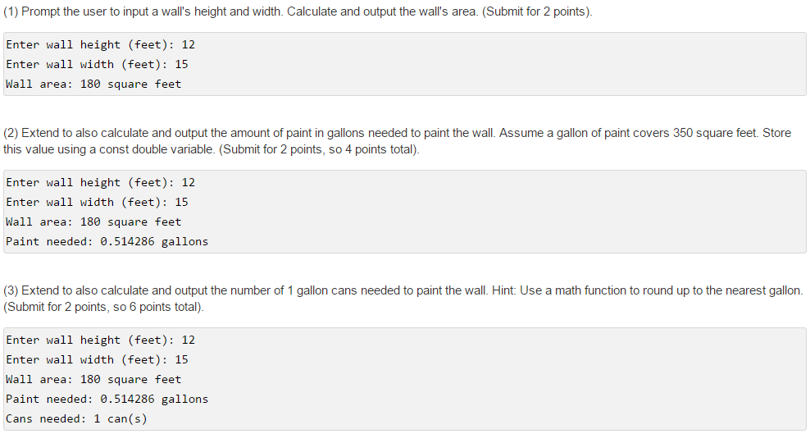
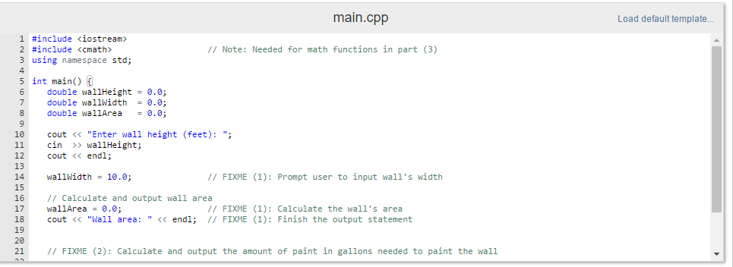

#include <iostream>
#include <cmath> // Note: Needed for math functions in part (3)
using namespace std;

int main() {
double wallHeight = 0.0;
double wallWidth = 0.0;
double wallArea = 0.0;

cout << "Enter wall height (feet): ";
cin >> wallHeight;
cout << endl;

wallWidth = 10.0; // FIXME (1): Prompt user to input wall's width

// Calculate and output wall area
wallArea = 0.0; // FIXME (1): Calculate the wall's area
cout << "Wall area: " << endl; // FIXME (1): Finish the output statement

// FIXME (2): Calculate and output the amount of paint in gallons needed to paint the wall

// FIXME (3): Calculate and output the number of 1 gallon cans needed to paint the wall, rounded up to nearest integer

return 0;
}

